# Victor Leao – 481212 – ECM2V.Ec – Personal Portfolio 4

|  |  |
| --- | --- |
| Week 4.3 | Research |
| Week 4.4 | Starting a Project / Char Controller / Level / HUD |
| Week 4.5 | Collectibles / Components / Tools |
| Week 4.6 | Collectibles Logic / Open Door / Door’s Leds / Material dressing |
| Week 4.7 | Adding Sfx / End Game |

Contents

Victor Leao – 481212 – ECM2V.Ec – Personal Portfolio 4 1

Learning Outcome 2 2

Introduction 2

What is this document, and what it’s not 2

Glossary 2

Week 4.3 3

The Unreal Engine 3

Unreal for Unity Developers 3

Understanding the Basics 3

Unreal Terminology 4

Game Mode, Game State, Player State 4

Week 4.4 4

Starting a Project 4

First Try 5

Create Some Game Templates and Test Explore Them 5

The IDE 6

Switch from Visual Studio to Jetbrains CLion 6

Rider for Unreal (preview edition) - Windows 6

The Character Controller 6

The Level 6

The HUD 7

Creating the Main Menu 7

Week 4.5 9

Creating a Collectable Item 9

Week 4.6 10

Creating Tween Components for “Perfumary” (Set Dressing) 10

Collectibles Logic 11

Creating the Exit Door 12

Creating the Door’s LEDs 12

Creating the End Level Trigger Box 12

Creating the Resolution Screen 12

Week 4.7 12

Adding Sfx 12

Building the game 15

The Build 15

Appendix 1 16

Blueprint Components 16

Blueprint Library 17

## Learning Outcome 2

“As a game developer, I want to improve my knowledge in **Unreal Engine**, for this, I want to develop a simple 3D game level with features like collect/delivery items, UI, and character controller. For this tool, I'll spend 40h of working/studying time. With this achievement, I'll have a better understanding of Unreal Engine and the deliverable will be a small demo scene.“

## Introduction

This document is a walkthrough of my learning process, I’ve already used Unreal before but just to test it and see “how it like”. Never spent more than an hour on it.

## What is this document, and what it’s not

This document is not a comprehensive step-by-step on how to create a simple game, neither a tutorial. It’s more a step-by-step of the learning process.

This was not written linearly too, some remarks/annotations were created during the learning accordingly with the insights acquired.

## Glossary

|  |  |
| --- | --- |
| Term | Meaning |
| Bp | Blueprint |

# Week 4.3

## The Unreal Engine[1]

* First Release in 1998 with the game Unreal
* UnrealScript (UScript) and **UnrealEd** (a level editor)

|  |  |
| --- | --- |
| Figure 1 - UnrealEd (1998) | Figure 2 - Unreal 4.26 (2021) |

PS:

***Some elements are still there, 23 years old!***

## Unreal for Unity Developers

List of some resources to startup

* <https://docs.unrealengine.com/4.26/en-US/Basics/UnrealEngineForUnityDevs/>
  + Unity users **must read it.**
  + Unreal Official Documentation
  + Quick Glossary Section
* <https://www.unrealengine.com/en-US/onlinelearning-courses/making-the-switch-from-unity-to-unreal-engine>
  + 2 hours length
  + Split into topics, short videos of approximately 5 minutes each
  + Unreal Official Source

## Understanding the Basics

The Unreal official documentation is the “first stop” to start learning it. Doesn’t need to read it all but use it for consulting

* <https://docs.unrealengine.com/4.26/en-US/Basics/>

## Unreal Terminology

* <https://docs.unrealengine.com/4.26/en-US/Basics/UnrealEngineTerminology/>
  + Actor? Pawn? Character?
  + **Game mode**
  + Player State
  + Game State

***Some terminology is in an OOP(Object Oriented Programming) approach and some “concepts” looks like to much tied***

## Game Mode, Game State, Player State

* A lot of premade rules
* Customizable
* Designer friendly

***Game Mode has too much responsibility and it is too much invasive, really strange for Unity Devs. Must learn it!***

# Week 4.4

## Starting a Project

Before reading the documentation, I believe 99%[2] of users install the Engine and try to “start doing things”. I did the same and easily got lost.

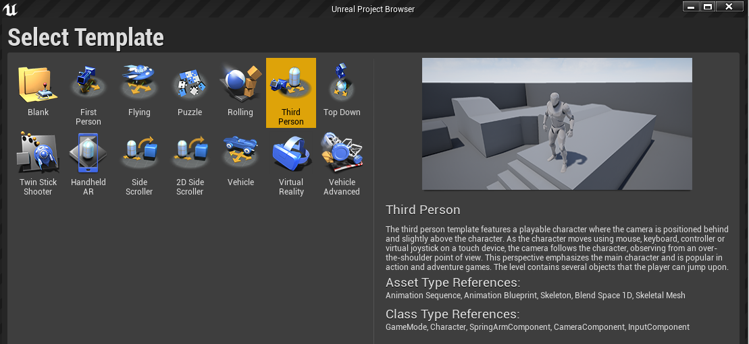

Figure 3- Lots f Templates

### First Try

1. Third-person Template Project
2. High Quality
3. Ray Tracing Enabled
4. Starter Content Pack

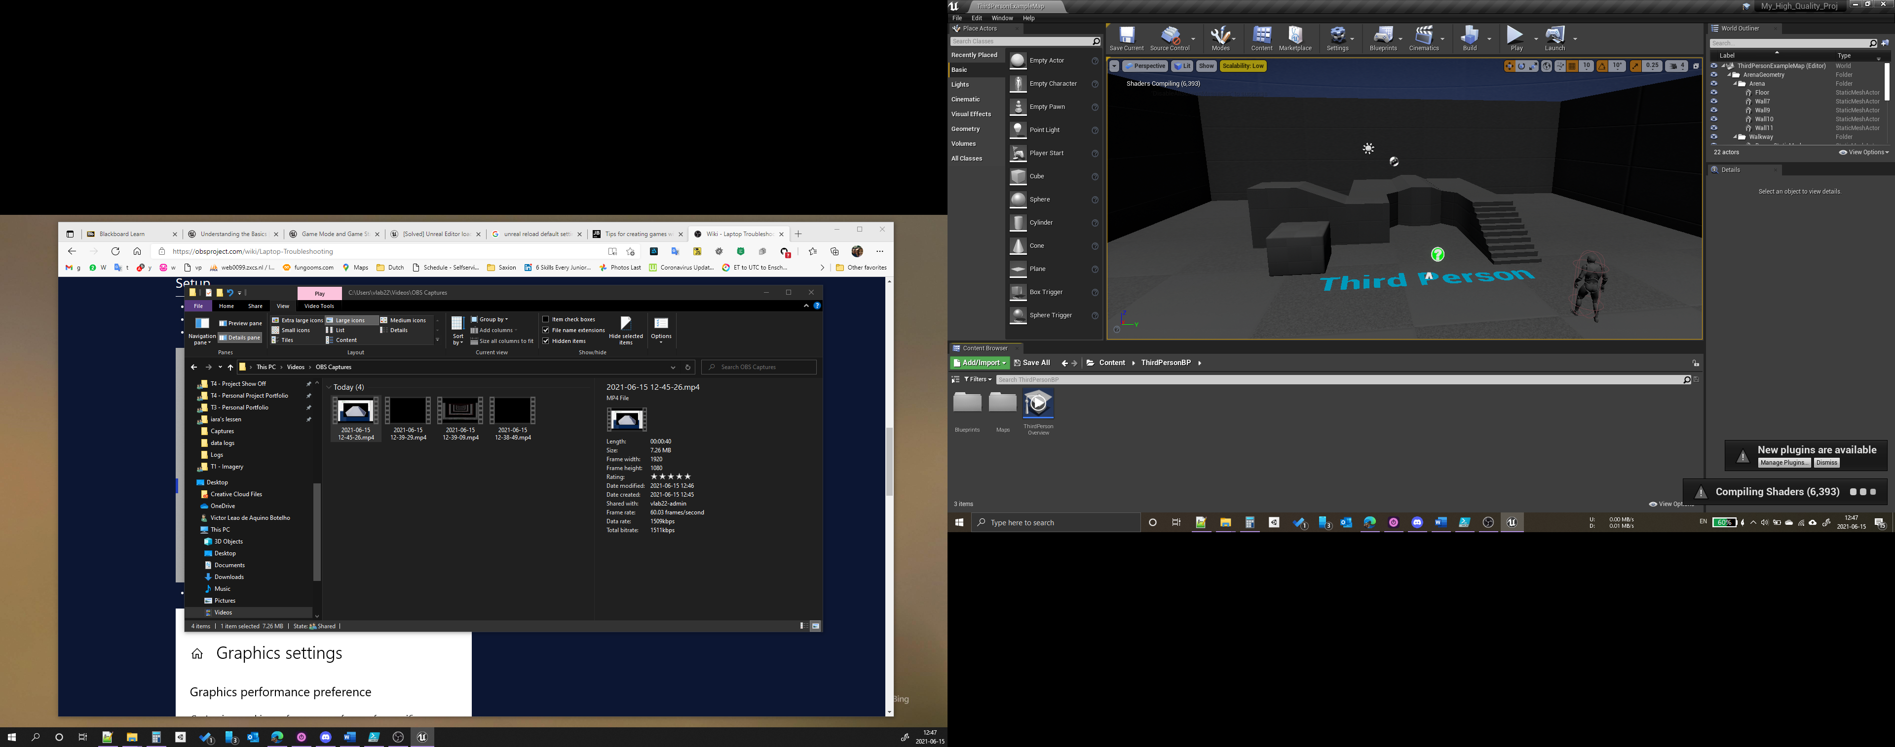

***30 minutes of loading to start the project***

### Create Some Game Templates and Test Explore Them

1. Third-person, Flying, Side Scroller, Top Down
2. High Quality
3. Ray Tracing Disabled
4. Starter Content Pack

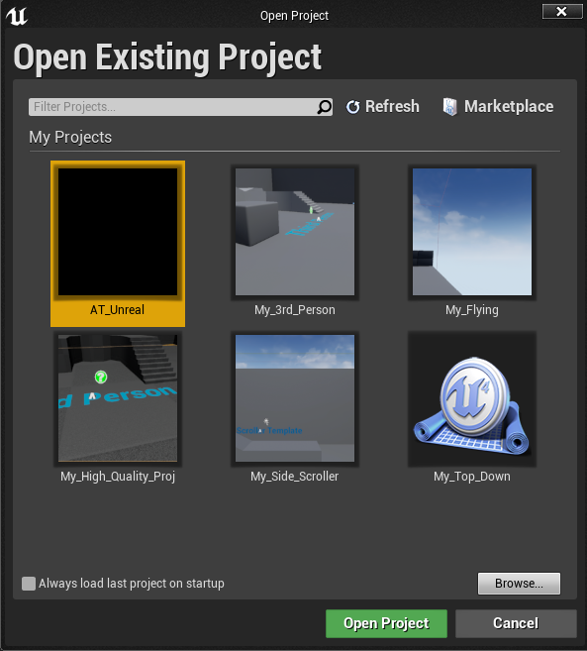

## The IDE

My first try to open Visual Studio for UE4 was not satisfactory:

* Slow
* Undesirable code completion

***In Unity, Jetbrains Rider is better than Visual Studio.***

***So let’s try another Jetbrains product, CLion for Unreal***

## Switch from Visual Studio to Jetbrains CLion

* <https://blog.jetbrains.com/clion/2016/10/clion-and-ue4/>
* <https://manenko.com/2021/05/18/how-to-make-unreal-engine-work-correctly-with-clion.htm>

***Unfortunately, the steps above only works for Mac/Linux***

## Rider for Unreal (preview edition) - Windows

* <https://www.jetbrains.com/lp/rider-unreal/>
  + Preview Edition download
* <https://www.jetbrains.com/help/rider/Unreal_Engine__Before_You_Start.html#rider_ue_plugins>
  + Instructions on how to use it
  + Works great!

## The Character Controller[3]

The Third Person Template Project already has a character controller with enough nice features:

* Character Controller
  + Humanoid Model
  + Animations (Idle, Walking, Jumping)
  + Input Handle (WASD Movement)
  + Camera Movement (Mouse)

## The Level[4]

The Third Person Template Project already has some level structure:

* Floor
* Walls
* Stairs

## The HUD[5]

* <https://docs.unrealengine.com/4.26/en-US/InteractiveExperiences/UMG/QuickStart/>
* Using this as a guide is possible to create some HUD like:
  + Main Menu
  + In-Game HUD
  + Pause Menu

### Creating the Main Menu

* <https://docs.unrealengine.com/4.26/en-US/InteractiveExperiences/UMG/HowTo...>
  + Easy going how to understand the UI + Elements

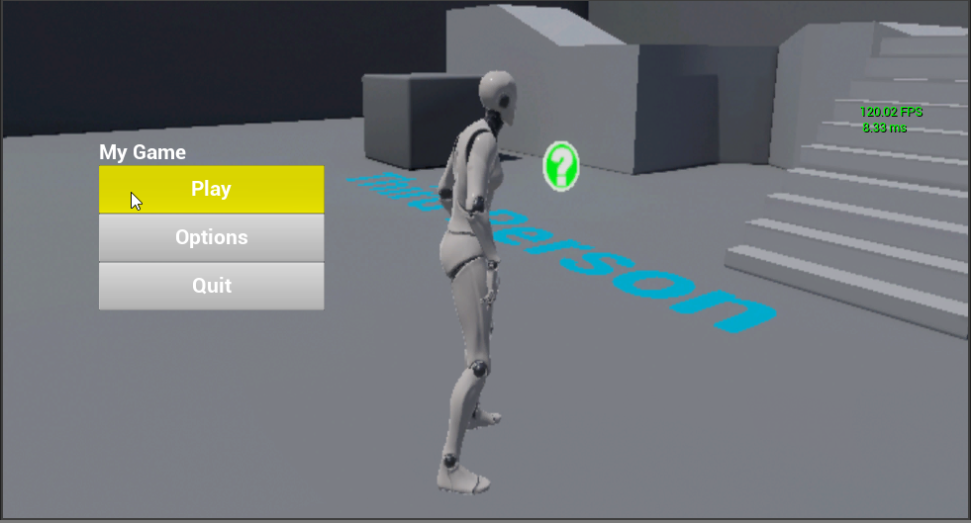

Figure 4 - Main Menu

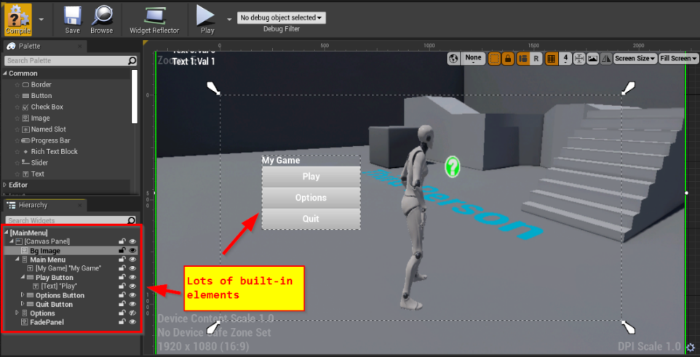

Figure 5 - UMG Editor (HUD)

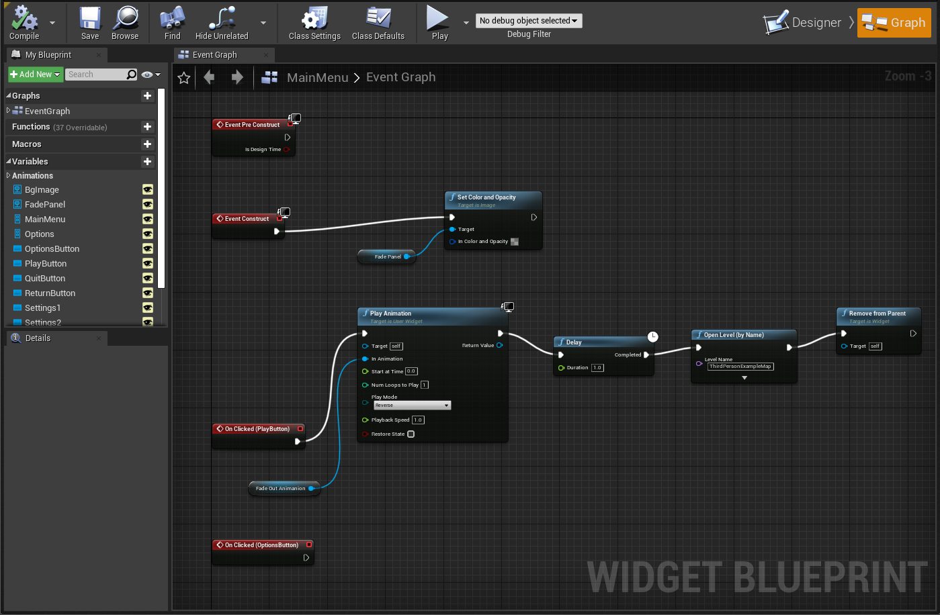

Figure 6 - Button action to Fade in Effect Panel and Load a Scene (Blueprint[6])



Figure 7 - Fade In-Out panel (GIF animation)

# Week 4.5

### Creating a Collectable Item[7]

* Features:
  + Load Disabled
  + Enable after some event happen
    - Level loaded or
    - After a delay or
    - Player do something
  + Disable when the Player Touch it
    - Play the particle effect
    - Fade out the object
* From scratch (only for guidance)
  + Drag a Sphere to the Level
  + Convert it to an Actor **Blueprint**
  + Add a Sphere Collision Component
  + Add an Explosion Particle
    - Unset: Activation -> Auto Activate (not play on start)
  + Create some reusable Blueprints (Appendix 1)
    - Listener to Activate the Actor when the Level is loaded (could be another event)
    - Disable Actor On Begin
    - Fade Out And Disable
    - Raise Event when touched by Player

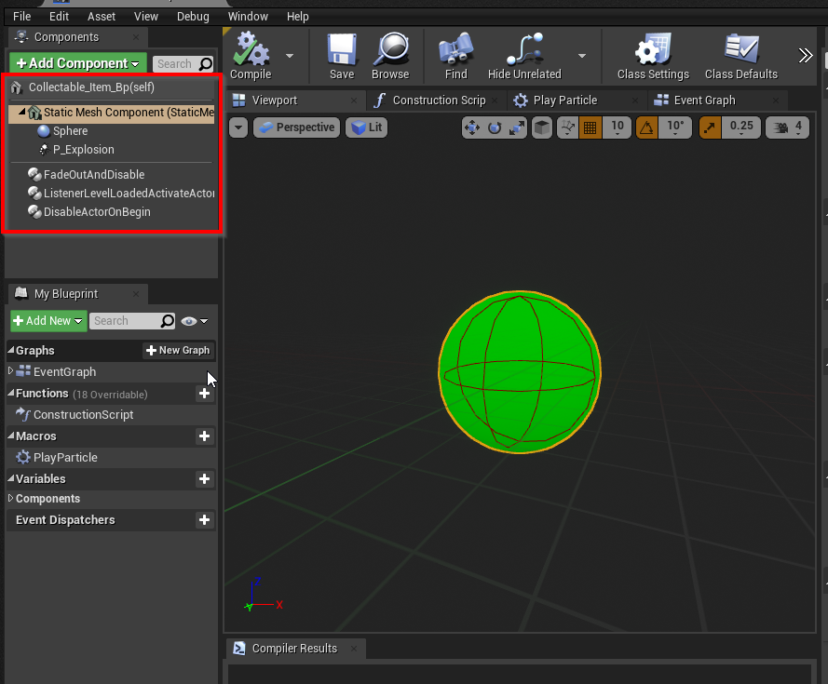

Figure 8 - Collectible Bp Structure

# Week 4.6

### Creating Tween Components for “Perfumary” (Set Dressing)

Even for a simple prototype, it’s good to look through some “set dressing” features.  
With some research in the Unreal MarketPlace no “free” asset was found.

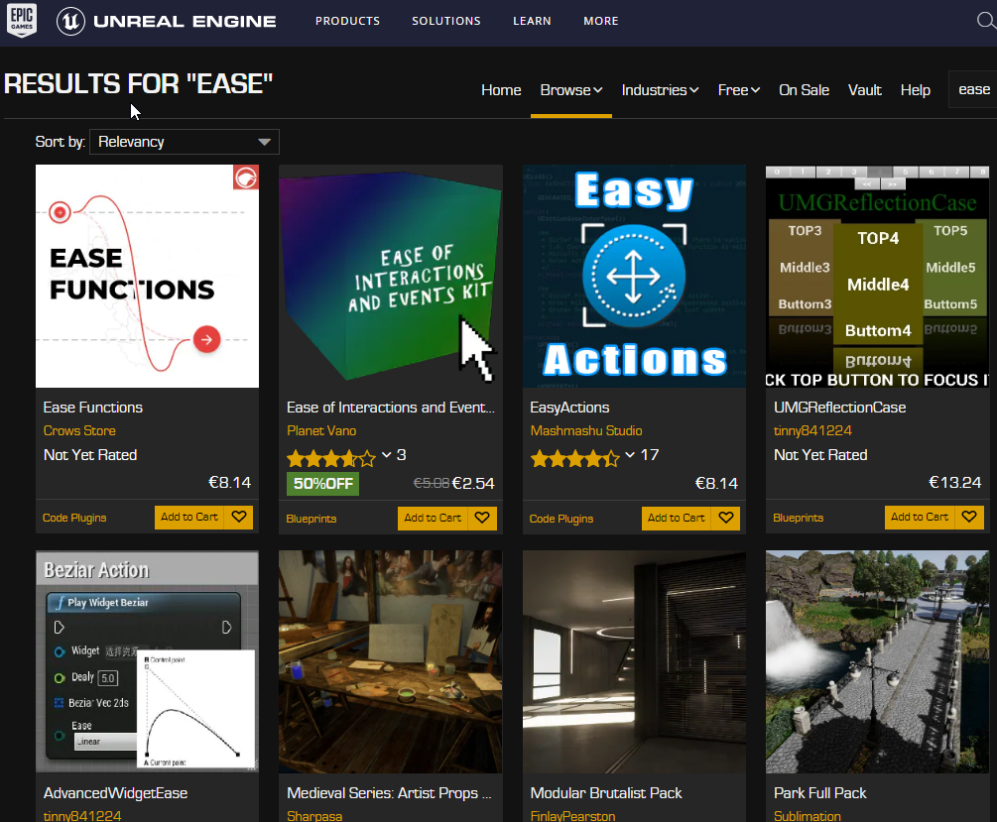

Figure 9 - MArketplace

So, some components were created.

* Tween Base
* Tween Rotate (can extend to TweenMove, etc)
* Tween Ease Out Elastic Scale

These Bps can be added to an Actor and be reusable (Designer Friendly)

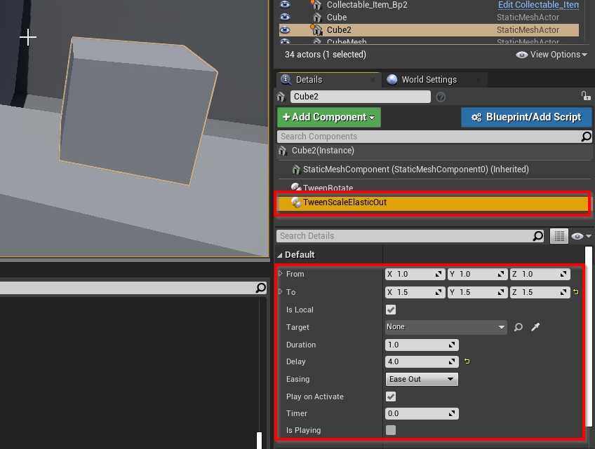

Figure 10 - A Tween Component with some parameter



Figure 11 - Tween Scale Elastic Ease Out Example

### Collectibles Logic

1. Collectable_Manager_Blueprint
   * Designer feed the “Total List” var in the Bp with the Colelctibles Items in the Level (Figure 12)
   * Listen to Item Touched Events
   * Raise Item Collected Event (to other Actors, the UI, Sfx, etc)
     + Door’s leds light up
   * Management (Count) Items collected
   * Raise Event when all items have been collected
     + Door Bp Open

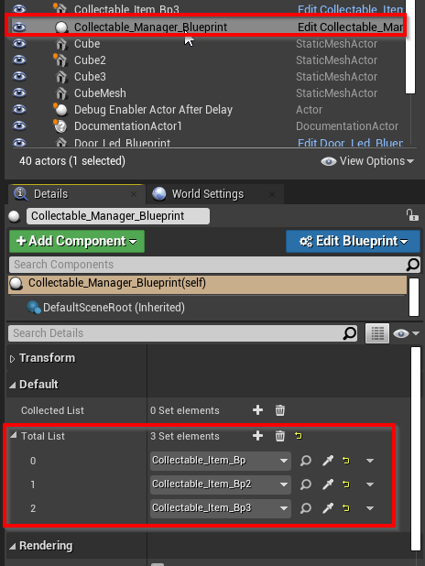

Figure 12 - Collectable Manager



Figure 13 - Getting Items and Opening the door

### Creating the Exit Door

* Re-using the starter pack Door Mesh
* Re-using a TweenRotate component
* Re-using the **ListenerAllCollectibleTakenBase**
* Extended to *DoorListenetAllCollected*
* When the player pickup all collectibles, the Collectibles Manager raise an Event
  + The door has a listener to it and the TweenRotate rotates the door (with a small delay)

### Creating the Door’s LEDs

* Simple spheres with an unlit material and a colored light
* Listen to the Collectibles Manager Event (Item Taken Event)
  + Change the color of the light (using Material Instancing)

### Creating the End Level Trigger Box

* After the exit door, a box trigger raises an ***End Level Tigger Touched*** event when the player touches it
* *Level_End_Controller_Blueprint* listens to this event and raises an ***End Level Event.***
  + *HUD FadePanel plays to fade the screen to black*
  + *Level_End_Controller_Blueprint* opens the next level (after a small delay)

### Creating the Resolution Screen

* A HUD element, just a fade panel, some text and Reset/Quit Buttons
* The last level loads the Resolution Level and the game ends

# Week 4.7

## Adding Sfx

* <https://docs.unrealengine.com/4.26/en-US/WorkingWithMedia/Audio/>
  + Extensive docs about audio, not necessary for prototyping
* <https://www.youtube.com/watch?v=u1iwQBwafNI>
  + A simple tutorial, doesn’t need to watch it completely
  + Easy to add a music

#### Footsteps

* Added in the Run Animation, synchronized with the feet

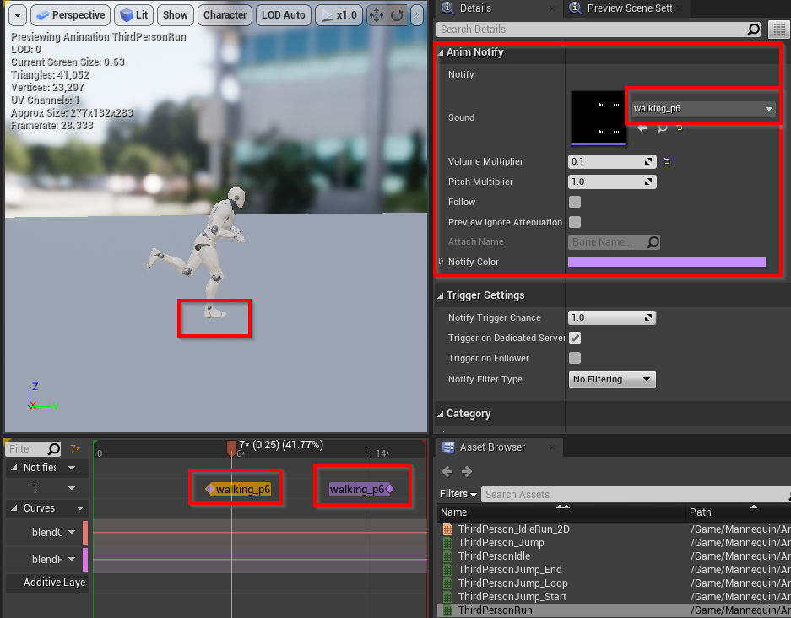

Figure 14 - Built in Play Audio Event attached to the key frame

* Same for jump sound

#### Collectables Sfxs

* Re-using the **ListenerCollectibleTakenBase**
* Extended to *ItemCollectedSfxListener*

*Door Opening Sfx*

* Re-using the ***DoorListenetAllCollected***
* Plays the audio component attached to the door Bp

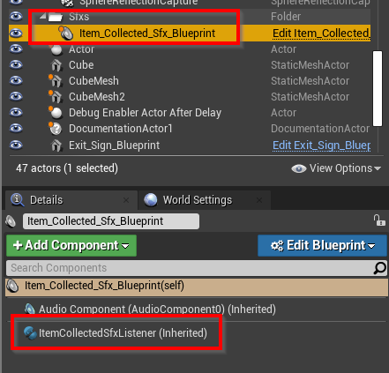

Figure 15 - Structure Example

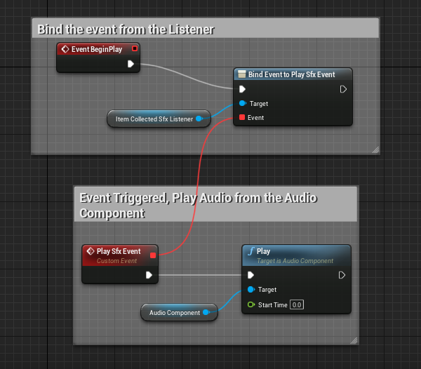

Figure 16 - Play Audio using Event

### Building the game

* Straight forward
* <https://www.youtube.com/watch?v=4b8Q6DwqEKc>
  + Video tutorial points some interesting fields to fill

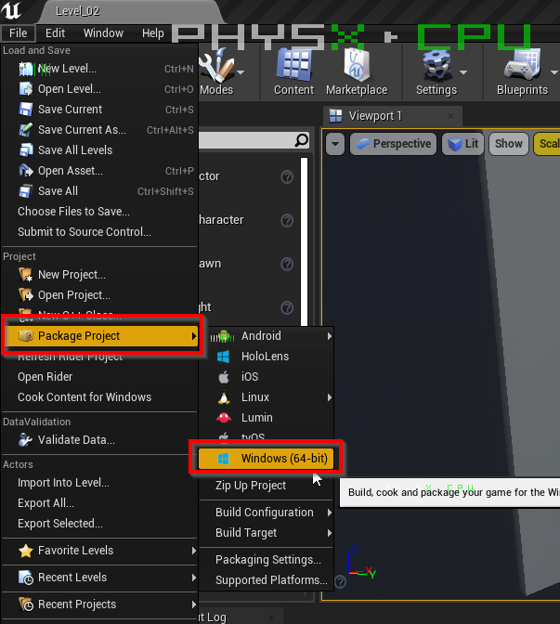

# The Build

### Win-64

Onedrive: <https://1drv.ms/u/s!AgtgYYr28Kkgg5E8rDuPXoF_UQujAg?e=vYHsDl> (690Mb)

# Appendix 1

Some reusable Components and Functions

## Blueprint Components

#### Fade Out And Disable Actor (Component)

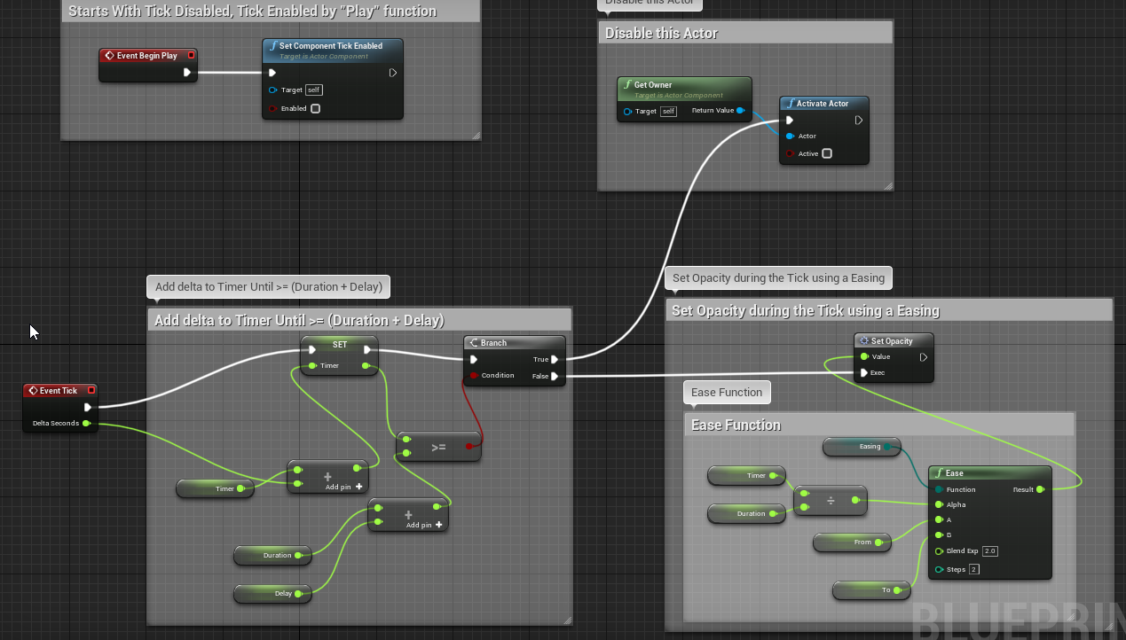

Figure 17 - Figure 18 - Fadeout and Disable Actor Component Bp

#### Disable Actor On Begin (Component)

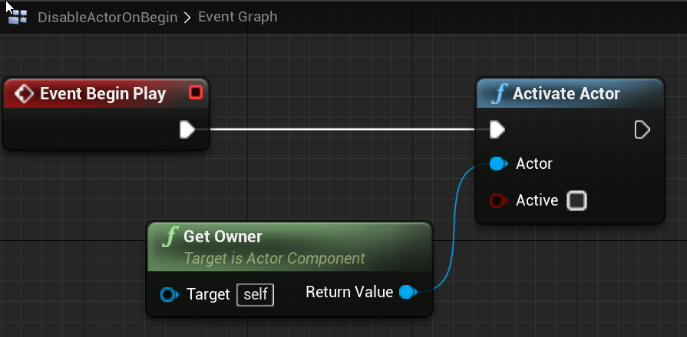

#### Listener Level Loaded And Activate Actor

* AfterLevelLoaded_Event is raised somewhere else, is not the responsibility of this Bp Component to deal with it.

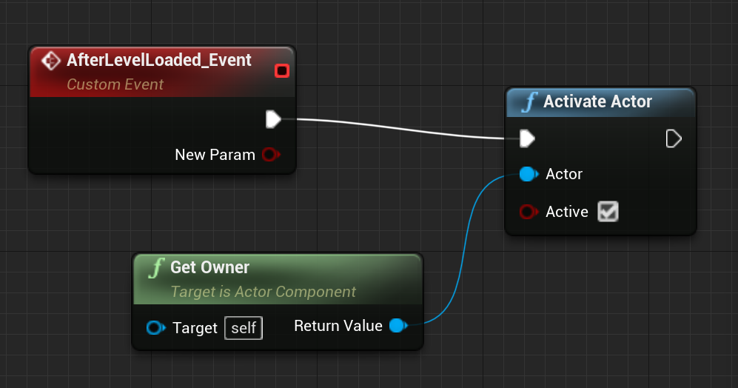

#### Tweens Components

* Tween Elastic Ease Out
* Tween Rotate

## Blueprint Library

* Collection of reusable Bp functions
* It’s not a Blueprint
* Add -> Blueprints -> Blueprint Function Library

#### Activate Actor (Actor, boolean)

* Enable/Disable the set of built-in functions below:
* Set Actor Tick Enabled
* Set Actor Enable Collision
* Set Actor Hidden in Game

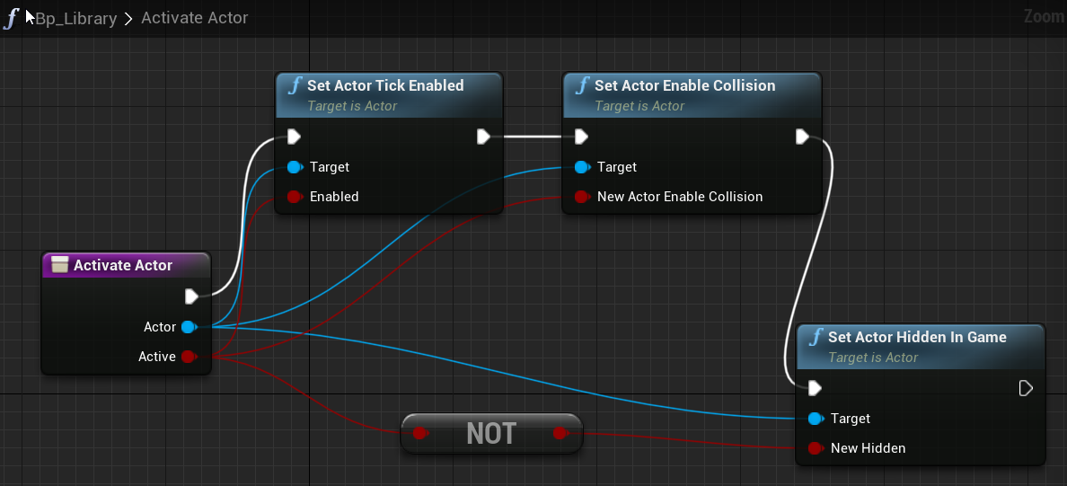

Figure 19 - Blueprint flow

1. <https://hotgates.eu/this-is-unreal-engine/>
2. No researched yet, I’ll try to grab some values about it
3. Portfolio Item
4. Portfolio Item
5. Portfolio Item
6. <https://docs.unrealengine.com/4.26/en-US/ProgrammingAndScripting/Blueprints/>
7. Portfolio Item